Sustaining the Digital Record: Preservation Risks in
Born-Digital Archival Materials

Keith Allen
keith.allen@usm.edu
March 11, 2026
Stacy Creel, PhD.
Brendan Fay, PhD.

INTRODUCTION
The rapid growth of born-digital materials has transformed the work of libraries, archives, and research institutions. Increasingly, scholarly outputs, research datasets, and cultural records are created and preserved exclusively in digital form rather than through physical media. Although digital technologies provide unprecedented opportunities for dissemination and access, they also introduce complex challenges related to long-term preservation. Unlike analog materials, digital objects depend on evolving technological environments for continued usability. As a result, digital files may become inaccessible when the software, hardware, or file formats required to interpret them are no longer supported (Hedstrom, 1997; Conway, 2010).
One of the most significant threats to digital collections is file format obsolescence. File formats define how digital information is structured and interpreted. When formats become outdated or unsupported, the content may no longer be accessible without specialized tools or migration strategies. Early research emphasized the fragility of digital formats and the risks associated with technological change (Lawrence et al., 2000). Subsequent scholarship has reinforced the need for proactive monitoring and preservation planning to ensure continued access to digital materials (Lavoie, 2014; Rosenthal, 2018). As digital collections expand in scale and complexity, understanding the distribution and preservation risk of file formats has become an essential component of digital stewardship.
Institutional repositories play an increasingly important role in storing, curating, and providing access to digital scholarship. These repositories store a wide range of materials, including research datasets, images, multimedia objects, and software outputs created across multiple academic disciplines. Studies have shown that institutional repositories have become essential components of research infrastructure, supporting both open access and long-term preservation (Narlock et al., 2024; Phillips, 2015). However, the diversity of file types deposited within repositories creates preservation challenges because repositories must support formats originating from many disciplinary practices and technological environments.
Digital preservation frameworks such as the Open Archival Information System (OAIS) provide conceptual guidance for managing digital assets and maintaining long-term access to digital information (Consultative Committee for Space Data Systems, 2012). Much of the literature on digital preservation focuses on policy development, preservation maturity models, or institutional readiness for preservation programs (Ahmad et al., 2022; Kaczmarek, 2017; Ndegwa, 2022). These studies provide valuable insight into governance structures, organizational capacity, and preservation planning. However, they often emphasize institutional readiness rather than examining the technical characteristics of the digital materials stored within repositories.
Despite these developments, comparatively fewer studies examine the actual files stored within repositories to determine which formats they contain and what preservation risks those formats may present. Understanding the distribution of file formats within repository collections is important for assessing potential long-term accessibility challenges. Empirical analysis of repository content can reveal patterns of format use that may not be visible through policy or governance research alone. Such analysis provides practical insight into how format-related preservation risks emerge within real-world repository environments. Examining the technical composition of repository collections therefore represents an important step in developing evidence-based digital preservation strategies.
Research Gap
Although digital preservation research has produced extensive frameworks and policy guidance, fewer empirical studies examine repository content to identify the file formats actually present within digital collections. As a result, much of the literature addresses preservation planning at a conceptual or institutional level rather than analyzing the technical characteristics of repository materials. Without direct analysis of repository collections, it remains difficult to understand how format-related preservation risks manifest in practice. Addressing this gap requires systematic analysis of repository files using automated format identification tools capable of evaluating large digital collections. Such analysis can provide empirical evidence that supports more effective digital preservation planning.
Recent scholarship has begun to emphasize the value of data-driven approaches for understanding digital preservation challenges. Studies examining format persistence, metadata quality, and repository systems demonstrate that large-scale analysis can reveal patterns and vulnerabilities that may not be visible through policy evaluation alone (Park & Tosaka, 2010; Rosenthal, 2018). Automated tools such as DROID and technical registries such as PRONOM allow researchers and preservation professionals to identify file formats at scale and evaluate potential preservation risks (Knight, 2015; The National Archives, n.d.). These tools enable systematic and reproducible analysis of digital collections.
This study built on these developments by examining file formats within datasets from the Harvard Dataverse repository. Harvard Dataverse is one of the largest open-access research data repositories and hosts datasets contributed by researchers across many disciplines. The platform’s openness, documentation, and API accessibility made it well suited for large-scale analysis of repository content (Harvard Dataverse Project Documentation, n.d.). By identifying the formats present in repository datasets and evaluating their preservation risk classifications, this study contributed empirical evidence to ongoing discussions about digital sustainability and long-term access to scholarly data.
Through automated format identification and quantitative analysis, this research identified the formats present within sampled repository files and evaluates their preservation risk. By examining actual content rather than relying solely on theoretical frameworks or policy analysis, the study provides insight into how format-related preservation challenges appear in real-world repository environments. This empirical approach helps clarify how technical characteristics of repository files may influence long-term accessibility. The findings are intended to inform digital preservation planning and demonstrate a practical workflow that libraries and archives can use to evaluate preservation risks within their digital collections.
Purpose Statement
The purpose of this study is to examine the file formats present within selected datasets from the Harvard Dataverse repository and to evaluate their potential preservation risks using automated format identification tools and format registry classifications. By analyzing repository-held files and identifying formats that may be vulnerable to technological obsolescence, the study aims to provide empirical evidence about preservation risks within institutional repositories. The research also seeks to demonstrate a replicable workflow for assessing digital format sustainability within repository environments. This approach contributes practical guidance for libraries and archives responsible for maintaining long-term access to digital collections. This analysis provides insight into the technical characteristics of repository-held files.
Understanding these characteristics helps institutions develop more effective preservation strategies.
Research Questions
R1: What image file formats are present in a random sample of image files from the Harvard Dataverse repository?
R2: What is the frequency distribution of these formats within the sampled dataset?
R3: Which formats exhibit characteristics associated with preservation risk according to documentation and software support recorded in the PRONOM registry?
R4: What proportion of the sampled files are stored in formats classified as sustainable for long-term digital preservation?
Definitions

Born-digital materials: Information objects that were created in digital form, as opposed to digitized from an analog source (Thibodeau, 2002).
Digital preservation: The series of managed activities necessary to ensure continued access to digital materials for as long as necessary (Lavoie, 2014).
File format obsolescence: The process by which a digital file format becomes unsupported by contemporary software or hardware, reducing its accessibility (Rosenthal, 2010).
Institutional repository: A digital collection managed by an institution that captures, preserves, and provides access to the intellectual output of a research community, including publications, datasets, and other scholarly materials (Lynch, 2003).
DROID (Digital Record Object Identification): A software tool developed by The National Archives (UK) that identifies file formats by comparing internal binary signatures against format signatures stored in the PRONOM registry (Knight, 2015).
PRONOM: A technical registry maintained by The National Archives (UK) that provides detailed information about file formats, including format signatures, version histories, and risks of technological obsolescence (The National Archives, n.d.).
Persistent Unique Identifier (PUID): A unique identifier assigned by the PRONOM registry to a specific file format signature, enabling digital preservation tools to identify and reference file formats consistently across systems (The National Archives, n.d.).
Format sustainability: The likelihood that a digital file format will remain accessible over time based on factors such as open documentation, widespread adoption, and continued software support (Lawrence et al., 2000).

Delimitations
This study is limited to files publicly accessible through the Harvard Dataverse repository. The analysis focuses exclusively on image files retrieved from the repository and does not examine other file types such as audiovisual materials, software files, or research datasets. The dataset analyzed in this study consists of a random sample of 1,600 downloadable files obtained through the Dataverse application programming interface (API). Proprietary datasets, restricted-access collections, and files not retrievable through the repository API are not included in the analysis.
The study is further limited to file format identification and preservation risk evaluation using the DROID format identification tool and documentation available in the PRONOM technical registry. Other digital preservation tools, registries, or risk classification frameworks are outside the scope of this research.
Assumptions
This study operates under several assumptions related to the research design and data collection procedures. It is assumed that the DROID format identification tool accurately identifies file formats by comparing file signatures with those documented in the PRONOM registry. The study also assumes that the technical documentation available in the PRONOM registry accurately reflects the characteristics and software support associated with the identified formats. Additionally, it is assumed that files retrieved through the Harvard Dataverse application programming interface represent valid and accessible repository content. The random sampling procedure used in the study is assumed to produce a dataset that reasonably reflects the range of image formats present within the repository. Finally, it is assumed that the sampled files have not been altered during the automated download and storage process used for analysis.
Significance of the Study
This study contributes to understanding the practical preservation challenges associated with born-digital materials in institutional repositories. As digital scholarship continues to expand, repositories are increasingly responsible for maintaining long-term access to diverse digital objects created across multiple disciplines. Ensuring that these materials remain accessible requires not only preservation policies and infrastructure but also an understanding of the file formats that repositories contain and the risks those formats may pose. Examining these formats provides insight into preservation challenges that may affect long-term accessibility.
Much of the existing literature on digital preservation focuses on conceptual frameworks, institutional policies, or organizational readiness for preservation programs (Ahmad et al., 2022; Kaczmarek, 2017; Ndegwa, 2022). While these studies provide valuable perspectives on preservation planning and governance, fewer investigations analyze the actual technical characteristics of files stored within repository collections. Empirical analysis of repository files can reveal patterns of format diversity, highlight potential vulnerabilities, and provide evidence-based guidance for preservation decision-making. Such analysis therefore complements existing theoretical and policy-oriented research within the field.
The study is also significant because it demonstrates a replicable methodological workflow for evaluating preservation risk within digital repositories. By combining automated file sampling, format identification tools such as DROID, and classification systems such as the PRONOM registry, the research illustrates how repositories can conduct systematic format audits of their collections. This approach allows preservation practitioners to identify formats that may require additional preservation attention and to prioritize preservation actions such as format migration, normalization, or enhanced documentation. Demonstrating this workflow also provides a practical model that other repositories can adopt when assessing the sustainability of their digital collections.
Institutional repositories are increasingly central to the research infrastructure, serving as platforms for data sharing, open scholarship, and knowledge dissemination (Narlock et al., 2024; Rieh et al., 2007). However, the long-term usability of repository content depends on the continued accessibility of the file formats in which that content is stored. By examining the presence and preservation status of formats within repository datasets, this study contributes to the body of scholarly literature in library and information science while also providing practical insight for librarians, digital archivists, and repository managers responsible for maintaining long-term access to born-digital materials.
Organization of the Study
The remainder of this study is organized into several sections. The Literature Review examines scholarship related to digital preservation, file format sustainability, and institutional repository infrastructures, with particular attention to research examining file format risks and automated preservation assessment tools. The Methodology section explains the research design, sampling procedures, automated data collection workflow, and the format identification and risk classification processes using DROID and the PRONOM registry. The Results section reports the identified file formats, their frequency distribution within the sampled dataset, and their associated preservation risk classifications. Finally, the Discussion and Conclusion interpret these findings in relation to the research questions and existing literature, discuss implications for digital preservation practice, and identify limitations of the study as well as opportunities for future research. Together, these sections provide a structured examination of repository file formats and their implications for digital preservation.

LITERATURE REVIEW
The long-term preservation of digital materials has become a central concern for libraries, archives, and research institutions. As scholarly communication and archival practices increasingly rely on digital formats, institutions must ensure that digital materials remain accessible despite ongoing technological change. Unlike physical artifacts, digital objects depend on technological environments that include file formats, software applications, and storage systems. Changes in any component of this environment can threaten the accessibility of digital information. Thus, digital preservation has emerged as a major focus within library and information science research. This literature review examines scholarship related to digital preservation theory, institutional repository stewardship, file format sustainability, and technical tools used to identify preservation risks. Together, these bodies of research provide the conceptual and methodological foundation for analyzing file formats within repository environments.

Digital Preservation Theory and Sustainability
Early scholarship on digital preservation emphasized the fragility of digital information and the potential for technological obsolescence to render digital content inaccessible. Hedstrom (1997) described digital preservation as a “time bomb” (p. 189), arguing that digital information requires continuous intervention to remain usable. Unlike traditional archival materials, which may survive for decades with minimal intervention, digital objects depend on evolving technological environments. Hardware platforms, operating systems, and software applications must remain compatible with the formats used to encode digital information. Without deliberate preservation planning, digital records risk becoming unreadable even when the underlying data remains intact.

Later research expanded on these concerns by examining the institutional challenges associated with sustaining digital collections. Conway (2010) distinguished between digitization and digital preservation, emphasizing that creating digital surrogates of materials does not guarantee their long-term accessibility. Although digitization initiatives have dramatically expanded access to cultural heritage resources, sustaining those resources requires ongoing investment in infrastructure, metadata management, and organizational planning. Digitization projects that lack sustainable preservation strategies may inadvertently produce digital content that becomes as vulnerable as the analog originals they replace.

Conceptual frameworks for digital preservation have been developed to address these challenges. The Open Archival Information System reference model provides one of the most widely adopted frameworks for managing digital collections over time (Consultative Committee for Space Data Systems, 2012). OAIS outlines the functional responsibilities of a digital archive, including ingest, storage, data management, access, and preservation planning. Lavoie (2014) explains how the OAIS model supports trusted digital repositories by defining processes required to maintain the authenticity and usability of digital objects. Within this framework, preservation planning plays a key role in monitoring technological change and identifying risks associated with file formats and software dependencies.

Researchers have also examined institutional readiness to implement digital preservation strategies. Kaczmarek (2017) introduced the Digital Preservation Capability Maturity Model (DPCMM), which provides a structured method for evaluating an institution’s preparedness for digital stewardship. The model identifies multiple levels of preservation maturity, ranging from inconsistent practices to fully integrated preservation programs. Studies of organizational preparedness suggest that many libraries and archives remain in the early stages of developing comprehensive preservation strategies. Ahmad, Rahman, and Karim (2022), for example, found that university libraries often lack the resources and technical expertise required to sustain long-term preservation programs. Similarly, Anyaoku (2019) observed that although institutions recognize the importance of preserving digital resources, systematic policies remain inconsistently implemented.

More recent research highlights the evolving nature of digital preservation challenges. Johnston (2020) notes that maintaining access to digital collections requires ongoing technological maintenance, institutional coordination, and sustained funding. As repositories grow in size and complexity, preservation systems must adapt to new formats, changing software environments, and evolving data management practices. The study concluded that institutions lacking coordinated preservation strategies face increased risk of long-term data loss and technological obsolescence. These findings underscore the importance of scalable preservation workflows capable of managing increasingly diverse digital collections.

Institutional Repositories and Digital Stewardship
Institutional repositories have become central infrastructures for storing and disseminating digital scholarly materials. Initially developed to support open access to academic publications, repositories now host a wide range of digital objects, including research datasets, multimedia materials, and software code. As repositories expand in scope, their role in digital preservation has become increasingly significant. Consequently, institutional repositories are increasingly recognized as important components of digital preservation infrastructure within academic institutions.

Early research on institutional repositories focused primarily on their role in supporting scholarly communication rather than long-term preservation. Rieh et al. (2007) conducted one of the earliest large-scale studies examining institutional repository development and management practices across multiple academic institutions. Their research analyzed repository policies and implementation strategies and found that repositories were often designed primarily as platforms for access and dissemination rather than systems intended to support long-term preservation. As a result, preservation functions such as format monitoring, migration planning, and sustainability strategies were frequently underdeveloped within early repository infrastructures. These findings highlighted the need for stronger integration of digital preservation practices into repository management.

Subsequent scholarship has emphasized the importance of integrating preservation strategies into repository infrastructure. Phillips (2015) examined the role of institutional repositories within broader digital preservation ecosystems and argued that repositories should be understood as components of long-term digital stewardship infrastructures. The study highlighted the importance of maintaining sustainable file formats, ensuring high-quality metadata, and implementing storage redundancy to support long-term accessibility. Phillips concluded that repositories lacking integrated preservation strategies may function effectively as dissemination platforms while still exposing digital materials to preservation risks.

The expansion of research data sharing has further increased the importance of repositories within scholarly communication systems. Narlock et al. (2024) analyzed the evolution of repository infrastructures within emerging research data ecosystems and found that repositories increasingly function as key components of knowledge infrastructures that support open science and collaborative scholarship. Their research demonstrated that repositories must accommodate a growing diversity of digital objects created across many academic disciplines. This diversity introduces additional preservation challenges because specialized or proprietary formats may require unique software environments or technical support. As a result, repository managers must consider format sustainability when designing repository preservation strategies.

Despite the growing importance of repositories, studies continue to identify gaps in preservation planning. Ndegwa (2022) investigated the presence of digital preservation policies within institutional repositories and found that many repositories lacked formal long-term preservation strategies or comprehensive risk management frameworks. The study reported that although repository managers recognized the importance of digital preservation, implementation of systematic preservation policies remained inconsistent across institutions. These findings suggest that many repositories continue to face challenges in integrating preservation planning into operational workflows.

Research evaluating the sustainability of digital curation systems further highlights these concerns. Rieger (2021) examined long-term digital curation infrastructures and concluded that effective preservation requires coordination between technical infrastructure, institutional policy, and organizational governance. The analysis demonstrated that repositories with integrated governance structures and dedicated preservation policies were significantly more successful in sustaining long-term digital access. Successful repository stewardship therefore depends on both technological solutions and sustained institutional commitment. Achieving this coordination remains an important challenge for institutions responsible for managing large and complex digital collections.

File Format Obsolescence and Preservation Risk
Among the many risks associated with digital preservation, file format obsolescence remains one of the most widely discussed. File formats define how digital information is structured and interpreted, determining how software renders digital content. When formats become unsupported by contemporary software, the data contained within those files may become inaccessible. As a result, monitoring format sustainability has become a central concern within digital preservation research.

Early research emphasized the importance of open documentation and widespread adoption when evaluating format sustainability. Lawrence et al. (2000) conducted one of the earliest systematic investigations of digital file formats and identified factors influencing long-term accessibility. Formats that are widely used, openly documented, and supported by multiple software platforms are generally considered more sustainable than proprietary or poorly documented formats. Their work established the principle that format selection plays a critical role in digital preservation planning.

Subsequent research has examined empirical evidence surrounding format obsolescence. Rosenthal (2018) analyzed format persistence across digital repositories and argued that although catastrophic format loss is less common than previously feared, sustainability cannot be assumed. Certain formats, particularly those associated with specialized software or proprietary systems, may still present long-term risks. Continuous monitoring of format usage is therefore essential for identifying potential preservation challenges.

Recent studies have also explored trends in format adoption within digital repositories. Krishnamurthy (2024) found that repositories often contain a mixture of widely supported formats and emerging formats associated with new technologies. This diversity creates varying levels of preservation risk, particularly when repositories accept materials from multiple disciplines with different technical practices. The study further demonstrated that repositories containing higher proportions of proprietary or specialized formats faced greater long-term preservation challenges. Monitoring format usage within repositories therefore provides important insight into potential long-term preservation challenges.

Research on the characteristics of digital objects further complicates format sustainability. Matthews et al. (2008) introduced the concept of significant properties, referring to the essential characteristics of digital objects that must be preserved to maintain their authenticity and functionality. Understanding these properties is critical when evaluating preservation strategies such as format migration or emulation. Preservation decisions must therefore consider not only file formats but also the functional attributes that define the integrity of digital objects.

Technical Tools for Format Identification and Risk Assessment
The increasing scale of digital collections has made automated preservation tools essential for repository management. One of the most widely used resources in digital preservation practice is the PRONOM technical registry maintained by The National Archives in the United Kingdom. PRONOM provides detailed documentation of digital file formats, including format signatures, version histories, software dependencies, and technical identifiers (The National Archives, n.d.). This information enables preservation systems to identify file formats and evaluate potential risks associated with their long-term accessibility.

Knight (2015) examined the development and application of DROID (Digital Record Object Identification), a digital preservation tool designed to identify file formats using signature-based analysis. The study explained how DROID compares the internal binary structure of digital files with format signatures stored in the PRONOM registry. Knight demonstrated that this approach enables repositories to analyze large collections of digital files efficiently while improving the accuracy of format identification compared with extension-based methods. The research concluded that automated identification tools such as DROID are essential for managing large digital collections containing thousands or millions of files.

Additional tools support complementary preservation workflows. Abrams and Luther (2010) explored the use of the JSTOR/Harvard Object Validation Environment (JHOVE) as part of digital repository management systems. Their study examined how validation tools can verify file integrity and confirm compliance with format specifications. The researchers found that combining format identification tools with validation systems improves the reliability and transparency of digital preservation workflows. These findings suggest that repositories benefit from integrating multiple automated tools when evaluating the technical characteristics of digital collections.

Research has also examined supporting infrastructure such as metadata systems used to manage digital objects. Park and Tosaka (2010) conducted a large-scale survey analyzing metadata practices within digital repositories. The study examined metadata records across multiple repositories and found substantial variation in metadata quality and consistency. Their findings demonstrated that incomplete or inconsistent metadata can affect the discoverability, management, and long-term preservation of digital resources. As a result, structured metadata practices play an important role in supporting automated preservation tools and repository management systems.

The development of these tools reflects a broader shift toward computational approaches to digital preservation. Automated analysis enables repositories to move beyond policy discussions and conduct empirical assessments of their digital collections. As digital repositories continue to grow in size and complexity, automated tools make it possible to evaluate large numbers of files efficiently. These technologies therefore play an important role in supporting scalable digital preservation practices and informing preservation planning decisions.
Emerging Challenges in Digital Preservation
Despite advances in preservation frameworks and tools, researchers continue to identify challenges affecting the sustainability of digital materials. One persistent concern involves the preservation of digital scholarly communication. Eve (2024) found that many digital scholarly journals lack adequate preservation coverage, raising concerns about the long-term accessibility of research outputs. These findings suggest that even widely distributed forms of digital scholarship may remain vulnerable without coordinated preservation strategies.
Other scholars have examined broader institutional challenges associated with digital preservation. Trognitz (2024) argues that preserving digital data outside formal archival infrastructures presents significant risks, particularly when preservation responsibilities are unclear. Without coordinated preservation strategies, digital materials may become fragmented across multiple systems with varying levels of technical support. This fragmentation can complicate efforts to ensure long-term accessibility and consistent preservation management.
Systematic reviews of digital preservation research further emphasize the complexity of these challenges. Jalaludin, Rahman, and Ismail (2025) identified recurring themes related to technological change, resource constraints, and policy development. Although preservation frameworks have matured over the past two decades, many institutions still face difficulties implementing sustainable preservation programs. These findings highlight the gap between theoretical preservation models and the practical realities faced by many organizations.
These challenges highlight the importance of empirical research examining the technical characteristics of repository content. Understanding the formats and structures of digital objects within repositories is a critical step in developing effective preservation strategies. By analyzing the technical composition of repository collections, researchers can identify potential risks that may affect long-term accessibility. Such analyses provide evidence that can inform preservation planning and digital stewardship practices.
Gap in the Literature
Across the literature, researchers emphasize the importance of monitoring digital preservation risks and developing sustainable stewardship practices. However, much existing research focuses on theoretical frameworks, institutional policies, or organizational preparedness rather than examining the technical composition of repository collections. As a result, the technical characteristics of digital objects stored within repositories are often less thoroughly studied than the institutional structures designed to manage them. Understanding the formats and structures of repository content is therefore an important component of effective digital preservation planning.
Relatively few studies conduct empirical analyses of file formats present within large institutional repositories. Consequently, the field lacks comprehensive evidence about how format distributions and preservation risks manifest within operational repository environments. Additionally, widely used open-access repositories such as Harvard Dataverse have received limited attention in format-based preservation studies despite their extensive multidisciplinary collections. Examining such repositories can provide valuable insight into the technical composition of digital collections that support contemporary research and scholarship.
By analyzing file formats within a sample of repository files using automated identification tools, the present study contributes empirical evidence to this area of research. Examining the prevalence and characteristics of file formats within repository datasets provides insight into potential preservation risks. These findings also clarify how format-related challenges appear within real-world repository environments. In doing so, the study supports more informed digital stewardship practices within institutional repositories.
Summary of the Literature
The literature reviewed in this chapter demonstrates that digital preservation has become a central concern for libraries, archives, and research institutions as digital collections continue to expand. Foundational scholarship emphasizes the fragility of digital materials and the risks associated with technological obsolescence, while frameworks such as the Open Archival Information System (OAIS) provide conceptual models for sustaining digital collections over time. Research on institutional repositories further highlights their growing role in preserving scholarly materials and research data, although many repositories continue to face challenges related to preservation planning and technological sustainability. Together, these studies establish an important foundation for understanding the technical and organizational factors influencing digital preservation practices.
Studies of file format sustainability identify format selection and monitoring as key factors influencing long-term accessibility. Formats that are widely adopted, openly documented, and supported by multiple software platforms are generally considered more sustainable than proprietary or poorly documented formats. At the same time, repositories often contain a mixture of established and emerging formats, creating varying levels of preservation risk. Understanding the distribution of these formats is therefore an important step in developing effective digital preservation strategies.
The literature also highlights the increasing importance of automated tools for analyzing digital collections. Resources such as the PRONOM technical registry and format identification tools like DROID enable repositories to evaluate file formats at scale and identify potential preservation risks within large collections of digital objects. These tools allow preservation practitioners to analyze the technical composition of digital collections more efficiently than would be possible through manual inspection. As digital collections continue to grow in size and complexity, automated analysis becomes increasingly necessary for effective preservation management.
Despite these developments, relatively few studies conduct systematic analyses of file formats within large institutional repositories. The present study addresses this gap by applying automated format identification and registry-based analysis to files retrieved from the Harvard Dataverse repository. By examining the formats present within repository datasets, the study contributes empirical evidence about format distribution and preservation risk. The following chapter describes the methodology used to collect, identify, and evaluate file formats within the sampled dataset.
Several studies reviewed in this chapter have applied computational tools and registry-based documentation to analyze the characteristics of digital collections. Similar to these approaches, this study employs automated format identification using the DROID software tool and technical documentation from the PRONOM registry to examine file formats within a repository environment. However, whereas many previous studies have focused primarily on preservation frameworks, institutional policies, or theoretical models of digital stewardship, this research emphasizes empirical analysis of the actual files stored within a repository. By combining automated file sampling, large-scale format identification, and registry-based preservation risk evaluation, the methodology extends previous work by directly assessing the sustainability of file formats present within repository datasets.

METHODOLOGY
Research Design
This study employed a quantitative content analysis of digital files using computational file format analysis tools. Quantitative content analysis was appropriate because it enabled the systematic examination of digital objects through measurable attributes, in this case format identifiers and their preservation characteristics. Rather than interpreting the meaning of digital content, the analysis focused on structural properties of files. Specifically, the study examined the encoding formats used for image data stored within a repository environment.
The research design integrated three methodological components: automated format detection, registry-based format documentation, and statistical analysis of format frequency. Automated format detection identified the technical structure of each file using signature-based identification tools. Registry documentation provided authoritative information about the characteristics and sustainability of each identified format. Statistical analysis was then used to examine the distribution of formats and evaluate their potential preservation risks within the dataset.
Sample Size Justification
The study analyzed a simple random sample of 1,600 publicly accessible image files drawn from the population of image files stored in the Harvard Dataverse repository. Because the repository contains millions of records, the required number of observations was determined primarily by the desired precision of estimates rather than the overall population size. Sampling allowed the study to estimate format prevalence without analyzing the entire repository collection. A random sampling strategy also reduced the likelihood of systematic bias in the dataset.
Format prevalence was measured as a proportion, such as the share of files encoded as JPEG, TIFF, or PNG. For large populations, the required number of observations for estimating a proportion was approximated using the standard proportion estimation formula. This formula estimates the sample size needed to achieve a specified level of statistical confidence and precision. It therefore provided a useful basis for determining an appropriate dataset size for the analysis.
$$n=\frac{Z^{2}p(1-p)}{e^{2}}$$
Using the standard normal approximation for proportion estimates at a 95% confidence level (Z = 1.96) (Creswell & Creswell, 2018) and the conservative assumption of maximum variability (p = 0.5), a dataset of 1,600 files produces a worst-case margin of error of approximately ±2.5 percentage points. This level of precision was sufficient to estimate the prevalence of common image formats and to determine the share of files that fall into preservation-relevant categories. A margin of error at this level provides reasonably stable estimates of format distribution within the repository sample. Consequently, the selected sample size provided an appropriate balance between statistical precision and practical feasibility.
A larger dataset also improved the likelihood of detecting rare formats that may pose greater preservation challenges. Rare formats may appear infrequently within repository collections but can still present important preservation risks. For instance, if a format occurs in approximately 0.1% of files (p = 0.001), a dataset of 1,600 files provides roughly an 80% probability of observing at least one occurrence. Detecting such formats is important for identifying potential preservation concerns within large digital collections.
The selected dataset size also reflects the efficiency of the programmatic data collection workflow used in this study. Image files were retrieved and processed using a Python script that queried the Harvard Dataverse API and downloaded eligible files automatically. Once the workflow was implemented, the number of files retrieved was controlled through a simple parameter specifying the dataset size. Consequently, collecting and analyzing 1,600 files required essentially the same programming effort as retrieving a much smaller set.
Taken together, these considerations make 1,600 files both a statistically appropriate and practically efficient dataset for examining format distribution and preservation risk within the repository. The sample size provides sufficient precision to estimate format prevalence while remaining manageable for computational analysis. It also increases the likelihood of capturing less common formats that may appear in repository datasets. For these reasons, the selected sample size supports both the analytical and practical objectives of the study.
Data Collection Procedures
Image files analyzed in the study were obtained from publicly accessible datasets hosted within the Harvard Dataverse repository. The platform stores research data contributed by scholars across numerous disciplines. Harvard Dataverse also provides an application programming interface (API) that supports automated retrieval of dataset metadata and associated files. This functionality makes the repository suitable for large-scale data collection and analysis.
A Python script was developed to query the Dataverse API and identify datasets containing downloadable image files. The script retrieved metadata records describing files available within repository datasets. Records were filtered according to file type metadata to ensure that only image-based content entered the candidate pool. This filtering process ensured that the dataset included only relevant file types for the study. A simplified excerpt of the Python sampling script used in this workflow is provided in Appendix A.
Eligible files were then randomly selected until the target dataset size of 1,600 files was reached. Random selection was used to reduce the likelihood of systematic sampling bias. Each selected file represented one observation within the analytical dataset. This procedure ensured that the dataset reflected a broad range of image formats present in the repository.
The selected items were downloaded programmatically and stored locally in a directory prepared for computational format analysis. Each file retained its original filename and extension as provided by the repository. Preserving these attributes ensured that associated format metadata remained intact during analysis. Maintaining the original file information also supported accurate format identification.
By retrieving files through the Dataverse API and applying random selection procedures, the resulting dataset represents a diverse cross-section of image formats deposited in the repository. This approach allowed the study to examine formats contributed by researchers across multiple disciplines. The resulting dataset therefore reflects a range of file creation practices and technical environments. Such diversity provides useful insight into format distribution within repository collections.
Technical Workflow and Reproducibility
Data collection and format identification were implemented through a reproducible computational workflow. The Python script used for sampling and downloading files interacts with the Harvard Dataverse API to retrieve dataset metadata. The script then locates eligible image files and stores selected items in a local directory for analysis. Automating this process reduces the likelihood of manual error and ensures that the same procedure can be applied consistently across datasets. As a result, the data collection workflow can be replicated in future studies using the same scripts and repository access methods.

Once the files were collected, the dataset directory was analyzed using DROID. The software examined each file and compared its binary signature against format signatures stored in the PRONOM registry. Binary signature matching allows DROID to identify formats based on internal file structure rather than relying solely on file extensions. This method improves the accuracy of format identification, particularly when file extensions are missing, incorrect, or inconsistent. Accurate format identification is essential for evaluating the preservation characteristics of digital files within repository environments.
The DROID output was exported in spreadsheet form for further processing. The resulting dataset contained metadata fields describing each identified file format and its associated identifiers. Subsequent analysis included extracting unique format identifiers and calculating frequency counts for each format within the sample. Each format was also linked to preservation information obtained from the PRONOM registry to evaluate sustainability characteristics. These steps allowed the study to assess both the prevalence of file formats within the dataset and their potential preservation risks.
Because the sampling script, DROID scanning process, and analytical procedures follow documented steps, the workflow can be replicated by other researchers. Applying the same tools and scripts to the Harvard Dataverse API would generate comparable datasets. Similarly, scanning the files using the same version of DROID and PRONOM signatures would produce consistent identification results. Replicating these procedures allows other researchers to verify the findings and evaluate the methodology in different repository environments. This reproducibility strengthens the methodological reliability and transparency of the study.
File Format Identification Using DROID
File format identification was performed using DROID (Digital Record Object Identification), a digital preservation tool developed by The National Archives in the United Kingdom. DROID determines file formats by comparing internal binary signatures with format signatures documented in the PRONOM technical registry. These signatures describe characteristic byte patterns that identify specific file formats. Using signature matching allows the software to detect formats even when file extensions are missing or incorrect. This approach improves the reliability of format identification and supports accurate analysis of digital files within preservation workflows.
After the sampled files were downloaded and organized locally, DROID scanned the dataset and analyzed the binary structure of each file. When a signature match was detected, the software assigned the file a Persistent Unique Identifier (PUID). Each PUID corresponds to a specific format entry documented within the PRONOM registry. This identifier provides a standardized method for referencing file formats within digital preservation systems. Using standardized identifiers allows researchers and preservation practitioners to analyze and compare format data consistently across digital collections.
The resulting report contained metadata fields including file name, file extension, format name, format version, and PUID. These fields provide detailed information about each identified file format and allow the formats to be categorized consistently across the dataset. The report therefore served as the primary dataset used for format analysis. Extracting this information made it possible to organize the data into a structured format suitable for quantitative evaluation. This organization allowed the study to examine the distribution of file formats within the repository sample and identify patterns relevant to preservation risk.
The format identification results produced by DROID were exported as a comma-separated values (CSV) file and compiled in Microsoft Excel for further analysis and categorization. A description of the dataset structure used for analysis is provided in Appendix D. The compiled dataset included key metadata fields such as file name, file extension, format name, format version, and the Persistent Unique Identifier (PUID) assigned by the PRONOM registry. These fields allowed the study to organize the format identification results into a structured dataset suitable for quantitative analysis. The compiled dataset was used to calculate the frequency distribution of identified formats and to evaluate preservation risk classifications based on documentation available in the PRONOM registry.
Files that could not be matched to a known signature were recorded as unidentified formats. Such cases may indicate uncommon file types or incomplete coverage within existing format registries. In some instances, unidentified files may also result from corrupted files or formats that have not yet been documented within the PRONOM registry. Identifying unmatched files can help preservation practitioners detect previously undocumented formats and highlight potential gaps in format registry coverage. In this study, the DROID output served as the foundation for subsequent analysis of format distribution and preservation risk.
Format Risk Assessment Using PRONOM
Following format identification, potential preservation concerns associated with the detected formats were evaluated using the PRONOM technical registry. PRONOM provides detailed documentation about digital file formats, including format specifications, software dependencies, and technical identifiers. This registry is widely used within digital preservation practice as an authoritative reference for documenting format characteristics. Consulting PRONOM therefore allowed the study to assess the sustainability of each identified format.
Because multiple files may share the same identifier, the analysis focused on unique PUIDs rather than individual records. Unique PUID values were extracted from the DROID output using spreadsheet filtering procedures. Each identifier was then queried within PRONOM to obtain technical information about the corresponding format. This approach ensured that the analysis examined distinct format types rather than repeated instances of the same format.
For each format entry, several characteristics were recorded in order to evaluate potential preservation concerns. These attributes were selected because they reflect common indicators of format sustainability discussed in digital preservation research. Information about documentation availability, software support, and technological dependencies can provide insight into the long-term accessibility of digital formats. The following characteristics were recorded for each format entry:
• Format name and version
• Availability of technical documentation
• Known software capable of rendering the format
• Dependencies on proprietary technologies or specialized software environments
• Evidence of continued software support
These attributes were used to evaluate format obsolescence risk, defined in this study as the potential inability to access or render the data contained within a file using currently supported hardware and software environments. Format sustainability was therefore assessed by examining both technical documentation and the level of software support associated with each format. Formats dependent on specialized or proprietary technologies may present greater preservation challenges over time. Evaluating these characteristics provided a structured method for assessing potential preservation risks.
Based on these characteristics, formats were grouped into three qualitative categories representing different levels of preservation risk. These categories provide a simplified framework for interpreting the sustainability of the formats identified in the dataset. The classification scheme reflects common preservation concerns related to documentation availability, software support, and technological dependencies. The three risk categories used in this study are defined as follows:
Low Risk: Formats with openly documented specifications and broad software support.
Moderate Risk: Formats with more limited support, partial proprietary dependencies, or declining adoption.
High Risk: Formats lacking reliable documentation, dependent on obsolete software environments, or inconsistently identifiable.
Data Analysis and Risk Classification
The DROID output spreadsheet was processed to determine the frequency of each identified format within the dataset. Duplicate entries were removed based on PUID values to generate a list of unique formats. Frequency counts were then calculated to determine how many files corresponded to each format. These counts provided a quantitative overview of format distribution across the sampled repository files.
Preservation-related information obtained from PRONOM was then used to assign risk classifications to each format. The criteria used to assign preservation risk levels are described in Appendix F. The resulting dataset contained information describing each format, the number of files encoded in that format within the study dataset, and the associated preservation risk category. This classification allowed the study to compare format prevalence with potential preservation risks. As a result, the analysis identified formats that may require closer monitoring within digital preservation workflows.
This consolidated dataset provided the basis for evaluating format distribution and potential obsolescence risks within the sampled repository content. By combining frequency counts with preservation risk classifications, the study was able to assess how commonly different levels of risk appeared within the dataset. The analysis also highlighted formats that may require additional attention from repository managers and preservation practitioners. These findings contribute to understanding the sustainability of formats used within repository collections.
Validity and Reliability
Several methodological considerations support the validity and reliability of this study. These considerations address how accurately the study measures preservation risk and how consistently the analytical procedures can be reproduced. Evaluating validity and reliability is important for ensuring that the findings accurately reflect the characteristics of the analyzed dataset. Together, these factors strengthen the credibility of the study’s methodology and results.
Internal validity is strengthened through the use of computational format analysis tools and standardized technical registries. File formats were identified using DROID, which relies on format signatures maintained within the PRONOM registry. Because identification is based on binary signature analysis rather than manual inspection, the procedure reduces the likelihood of subjective classification errors. This automated process ensures that format identification is applied consistently across all files included in the dataset.
Construct validity is addressed through the operational definition of preservation risk used in the study. Format obsolescence risk was defined as the potential inability to access or render data using currently supported hardware and software environments. Risk classifications were derived using technical information documented in PRONOM, including format specifications, software support, and technological dependencies. Using these documented technical attributes helps ensure that preservation risk categories are applied consistently across formats.
Reliability is supported through automated and reproducible procedures. The dataset was generated using a Python workflow that queried the Harvard Dataverse API and randomly selected eligible image files. Because the sampling process is parameter-driven, the procedure can be repeated using the same script and selection criteria. Likewise, the DROID scanning process produces standardized reports that can be reproduced by analyzing the same dataset using the same software version and PRONOM signature file.
Finally, transparency in the analytical workflow further supports methodological reliability. The procedures used to extract PUID identifiers, calculate format frequencies, and assign risk classifications are explicitly documented. This documentation enables other researchers to replicate the study using comparable repository environments and analysis tools. Clear documentation therefore contributes to transparency and reproducibility in digital preservation research.
Limitations
This study includes several limitations related to factors outside the researcher’s control. The dataset analyzed in the study was obtained from the Harvard Dataverse repository and therefore reflects the file formats present within a single repository environment. Other institutional repositories may contain different format distributions depending on disciplinary focus and repository policies. In addition, format identification relied on the accuracy and coverage of signatures documented in the PRONOM technical registry, which may not include every existing file format. Some files may also remain unidentified if their signatures are incomplete or not yet documented within available format registries. These factors may influence the completeness of format identification and the interpretation of preservation risk classifications.
RESULTS
This chapter presents the results of the automated format identification and preservation risk analysis conducted on the sampled dataset of image files retrieved from the Harvard Dataverse repository. The findings addressed the study’s research questions by identifying the file formats present in the dataset, examining their distribution, and evaluating their preservation risk characteristics using documentation from the PRONOM technical registry. The analysis provided insight into the technical composition of the sampled repository content. These results established the empirical foundation for the discussion of preservation implications presented in the following chapter. Together, these results provide a structured overview of the technical characteristics of the sampled repository files.
Research Question 1. What image file formats are present in a random sample of image files from the Harvard Dataverse repository?
The automated format identification process conducted using DROID analyzed 1,600 image files retrieved from publicly accessible datasets within the Harvard Dataverse repository. The analysis identified 22 unique file format identifiers (PUIDs), representing the range of image formats present within the sampled dataset. These identifiers corresponded to several major image format families, including JPEG, PNG, TIFF, GIF, JPEG 2000, and newer formats such as WebP and AVIF. The presence of these formats reflected the diversity of image encoding practices within repository datasets. A complete list of the identified formats and their preservation risk classifications is provided in Appendix E.
Although the dataset contains multiple versions or variants of certain formats, most files fell within a small number of widely adopted image format families. JPEG, PNG, and TIFF formats were particularly common within the sample. These formats are widely used in digital imaging workflows and are supported across many operating systems, software platforms, and web environments.
Figure 1 illustrates the distribution of major image format families identified in the sampled dataset. Format families were determined based on the PRONOM identifiers assigned during the DROID format identification process. The figure demonstrates that the majority of files belong to a small number of widely adopted format families commonly used in digital repositories.
Figure 1
Image Format Families Identified in the Sample Dataset (n = 1,600)

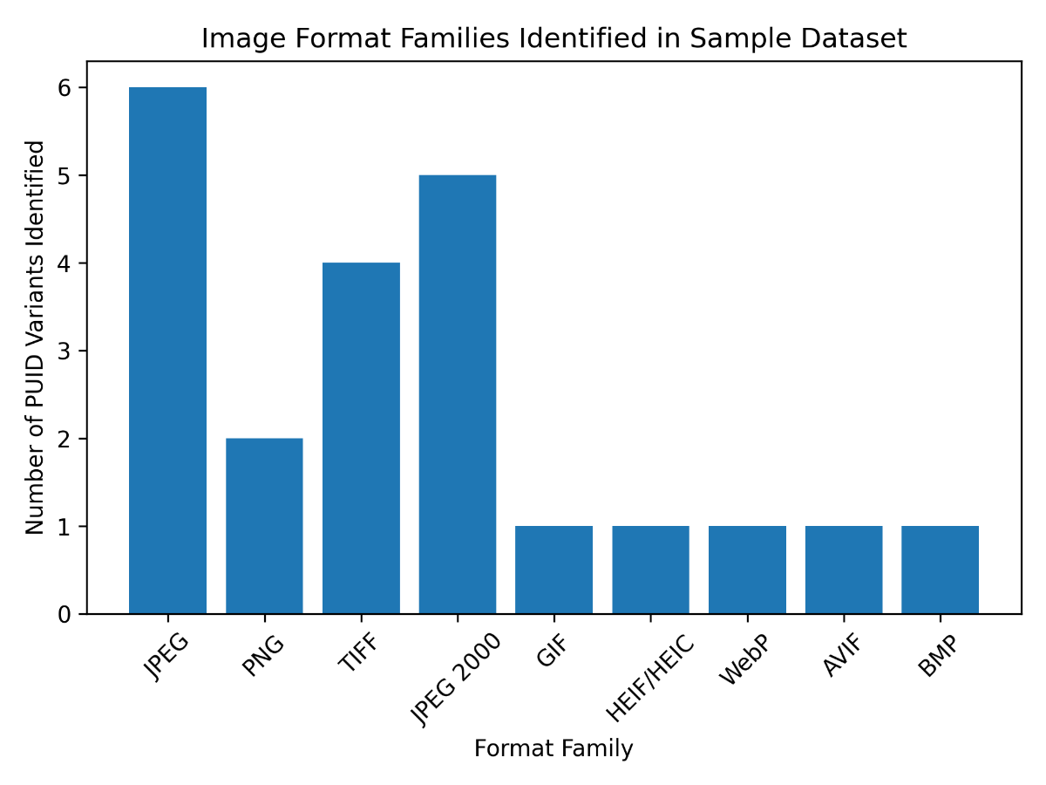
Note. Format families were determined based on the PRONOM identifiers assigned during the DROID format identification process. Counts represent the number of unique format identifiers (PUIDs) associated with each image format family.
Research Question 2. What is the frequency distribution of these formats within the sampled dataset?
Following format identification, the dataset was analyzed to determine the frequency distribution of the identified formats. The results indicate that a relatively small number of formats account for the majority of files within the sampled dataset. JPEG, PNG, and TIFF formats represent the most frequently occurring formats, while formats such as JPEG 2000, HEIF/HEIC, AVIF, and WebP appear less frequently.
The presence of multiple PUID variants associated with formats such as JPEG and TIFF reflects differences in format signatures or format versions rather than fundamentally different encoding standards. Files that appeared visually identical may correspond to slightly different internal format structures. Automated identification tools such as DROID distinguished these variants by analyzing internal binary signatures rather than relying solely on file extensions.
Figure 2
Distribution of the Most Commonly Identified Image Format Families (n = 1,600)
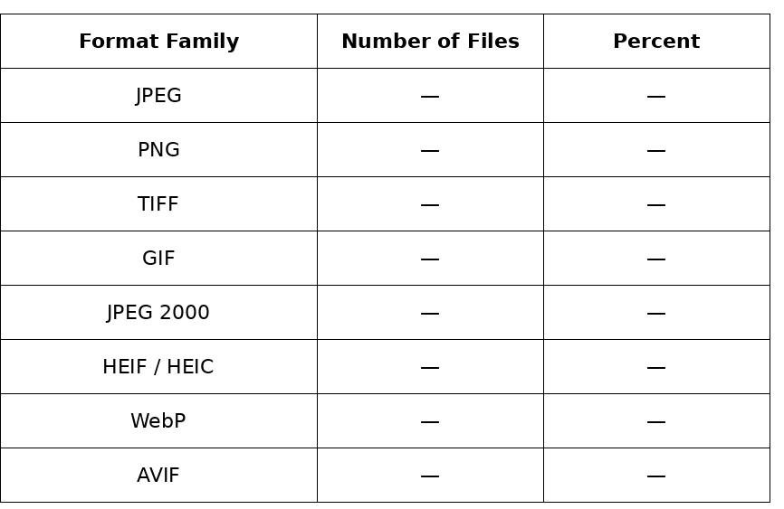
Note. Counts represent the number of files associated with each image format family identified within the sampled dataset of 1,600 files. Format families were determined based on PRONOM identifiers assigned during the DROID format identification process.
Research Question 3: Which formats exhibit characteristics associated with preservation risk according to documentation and software support recorded in the PRONOM registry?
After identifying file formats and calculating their frequencies, each unique format identifier was evaluated for preservation characteristics using documentation available in the PRONOM technical registry. Information related to format documentation, software support, and technological dependencies was examined in order to determine whether each format exhibited characteristics associated with potential preservation risk.
Formats with openly documented specifications and widespread software support were classified as low preservation risk. These include widely used formats such as JPEG, PNG, TIFF, and GIF. These formats are supported across multiple software environments and have well-established technical documentation, making them generally suitable for long-term digital preservation.
A smaller subset of formats—including JPEG 2000 variants, HEIF/HEIC, and AVIF—was classified as moderate preservation risk. Although these formats remain usable within modern software environments, they often rely on specialized codecs or exhibit more limited adoption than traditional image formats. These characteristics may introduce potential long-term access challenges if software support declines or if technological dependencies change.
No formats identified within the sampled dataset exhibited characteristics consistent with high preservation risk. All formats identified in the sample had available technical documentation and at least some degree of contemporary software support.
Research Question 4: What proportion of the sampled files are stored in formats classified as sustainable for long-term digital preservation?
The final stage of analysis examined the proportion of formats within the dataset that could be considered sustainable for long-term digital preservation. Based on the classification criteria used in this study, formats categorized as low preservation risk were considered sustainable due to their open documentation, widespread adoption, and broad software compatibility.
Of the 22 unique format identifiers identified in the dataset, 16 formats (72.7%) were classified as low preservation risk and 6 formats (27.3%) were classified as moderate preservation risk. These classifications reflect the relative distribution of format types within the dataset rather than the number of individual files encoded in each format. No formats were classified as high preservation risk according to the criteria defined in this study.
Figure 3 illustrates the distribution of preservation risk classifications among the identified formats.
Figure 3
Preservation Risk Distribution of Identified Image Formats
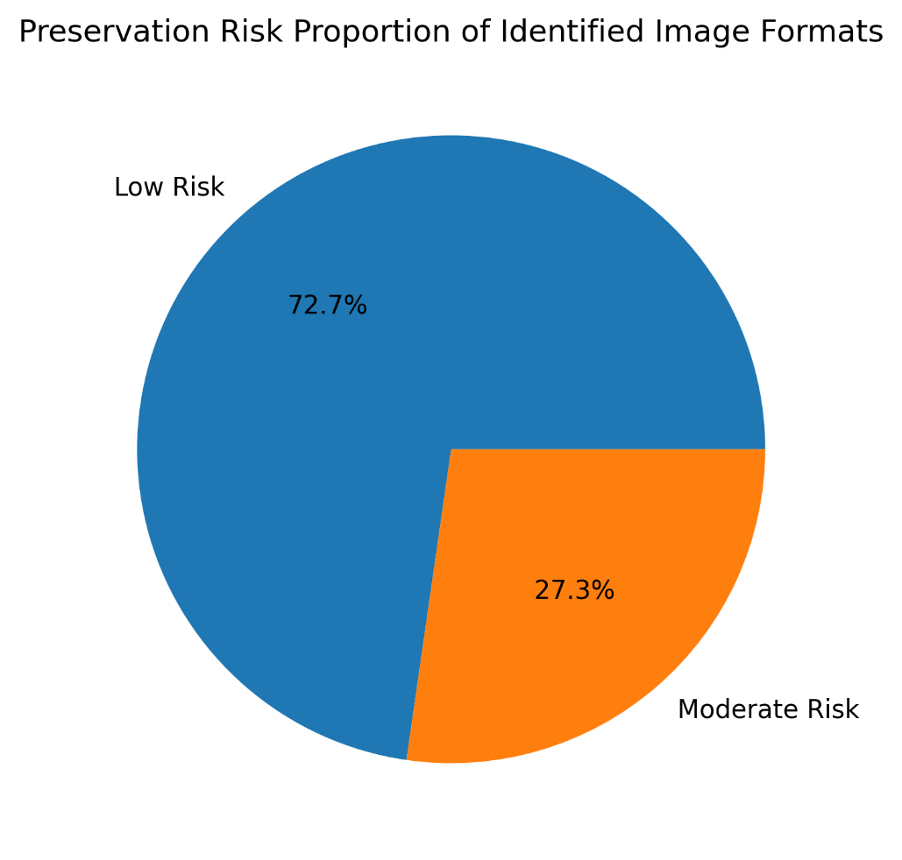
Note. Percentages represent the proportion of identified image file formats classified as low or moderate preservation risk based on documentation availability, software support, and technological dependencies recorded in the PRONOM technical registry.
Overall, the results indicated that the sampled repository content relies primarily on established and widely supported image formats. A smaller number of files were encoded in emerging or specialized formats such as AVIF, HEIF/HEIC, and JPEG 2000. These findings provide an empirical overview of the image file formats present within the sampled repository content and establish the basis for the discussion of preservation implications in the following chapter.
DISCUSSION
Opening Summary of Findings
Across the sampled dataset of 1,600 image files, 22 unique image formats were identified by DROID. Most corresponded to widely supported raster image formats—particularly JPEG, PNG, TIFF, and GIF—which are characterized by open documentation and broad compatibility across contemporary software environments. These formats were therefore classified as low risk for obsolescence. A smaller subset, including JPEG 2000 variants, HEIF/HEIC, and AVIF, was categorized as moderate risk due to more limited adoption or reliance on specialized software environments. Although these formats remain usable, their dependence on specific codecs or evolving software ecosystems may introduce long-term access concerns. No formats in the dataset were classified as high risk, suggesting that the sampled Harvard Dataverse image files are generally stored in formats with stable documentation and strong software support.
Answering the Research Questions
The findings of this study directly addressed the research questions by identifying the image file formats present within a sample of files from the Harvard Dataverse repository and evaluating their preservation risk characteristics. The analysis focused on understanding the technical composition of repository content and its implications for long-term digital preservation. By examining format distribution and associated preservation characteristics, the study provided empirical insight into the sustainability of image formats within a repository environment. These findings established a foundation for interpreting the preservation implications of the identified formats.
The first research question examined which image formats were represented in the sampled repository content. Automated format identification using DROID revealed 22 distinct file format identifiers (PUIDs). These identifiers represent several major format families including JPEG, PNG, TIFF, GIF, JPEG 2000, HEIF/HEIC, AVIF, and additional format variants. The results demonstrated that the repository sample contains a diverse range of image formats commonly used in digital collections.
The second research question considered which of these formats exhibit characteristics associated with preservation risk based on information documented in the PRONOM technical registry. Analysis of format documentation and software support characteristics indicated that most identified formats exhibit strong technical documentation and broad software compatibility. These formats were therefore classified as low risk. A smaller number of formats, particularly JPEG 2000 variants, HEIF/HEIC, and AVIF, were categorized as moderate risk due to their more limited adoption or dependence on specialized software environments.
The third research question examined the proportion of sampled files associated with preservation risk categories. The results indicated that the majority of files in the dataset are encoded in formats considered stable within current computing environments. Only a small subset of formats exhibited characteristics associated with moderate preservation risk. No formats were identified as high risk within the sampled dataset.
Together, these findings provide an empirical overview of file format distribution and preservation risk within the analyzed repository content. The results highlight the predominance of widely supported image formats within the dataset. At the same time, the presence of emerging formats demonstrates the evolving nature of digital imaging technologies. These findings contributed to understanding the preservation characteristics of image files stored in institutional repository environments.
Prevalence of Established Image Formats
The predominance of formats such as JPEG, PNG, and TIFF indicates that repository contributors frequently rely on image standards with extensive software support and long histories of adoption in digital imaging workflows. These formats are widely used across many software platforms and digital imaging applications. From a preservation perspective, these characteristics align with widely recommended best practices emphasizing open documentation and broad compatibility. The frequent use of these formats within the repository sample therefore suggests a relatively stable technical foundation for long-term access.
Previous research has shown that formats with widespread adoption and open specifications are more likely to remain accessible over time (Lawrence et al., 2000; Rosenthal, 2018). The results of this study support those observations, indicating that most sampled repository files are encoded in formats with strong documentation and stable software ecosystems. Consequently, the immediate risk of format-based access barriers within the sampled dataset appears relatively low. These findings reinforced the importance of format selection as a key factor in digital preservation planning.
The presence of multiple PUIDs corresponding to JPEG and TIFF variants also highlighted the complexity of format identification. Files that appear visually identical may correspond to different format versions or structural variations. Tools such as DROID and the PRONOM registry made it possible to detect these distinctions by analyzing internal file signatures rather than relying solely on file extensions. This capability was important for digital preservation workflows because different format variants may have distinct technical dependencies or preservation implications.
Emerging and Moderately Supported Formats
Although most formats identified in the dataset were categorized as low risk, several moderately supported formats illustrate the evolving nature of digital imaging technologies. Formats such as JPEG 2000, HEIF/HEIC, and AVIF were developed to improve compression efficiency and image quality compared with earlier standards. However, these formats often rely on specialized software environments or codec support that may not be universally available. These characteristics may introduce potential preservation challenges if software support declines over time.
JPEG 2000 provides a useful example. Despite offering technical advantages over traditional JPEG compression, adoption has been uneven outside specialized domains such as geospatial imaging, medical imaging, and digital preservation. As a result, software support for some variants remains more limited than for traditional JPEG formats. Similarly, newer formats such as HEIF and AVIF depend on modern compression technologies that continue to evolve within contemporary software ecosystems.
The presence of these formats within the repository sample highlights the need for ongoing monitoring of emerging technologies. As researchers adopt new tools for image creation and storage, repositories may encounter formats whose long-term sustainability is not yet fully established. Monitoring format adoption can help repositories identify potential preservation risks before they affect long-term accessibility. Proactive format assessment therefore remains an important component of digital preservation planning.
Implications for Repository Preservation Practices
The findings emphasize the importance of continuous format monitoring within digital repository environments. Digital preservation frameworks such as the Open Archival Information System (OAIS) stress the need for ongoing preservation planning and technological surveillance to maintain access to digital materials over time (Consultative Committee for Space Data Systems, 2012; Lavoie, 2014). Automated format identification tools such as DROID provide a practical mechanism for implementing this monitoring process. By routinely analyzing repository content, institutions can identify potential format-related preservation risks before they affect long-term accessibility.
Analyzing file formats at scale allows repositories to better understand the technical composition of their collections. This knowledge enables repository managers to identify formats that may require additional preservation attention, such as format migration planning or the maintenance of specialized rendering software. Large-scale format analysis also helps institutions track changes in format usage over time. These insights support more informed preservation decision-making within repository environments.
The methodology used in this study demonstrates how automated tools and format registries can be integrated into repository workflows. The combination of DROID format identification and PRONOM documentation provides a scalable approach for evaluating the sustainability of repository content as collections continue to grow in size and complexity. Integrating such tools into routine repository management practices can support systematic monitoring of digital collections. These workflows therefore contribute to more proactive digital preservation strategies.
Relation to Previous Research
The findings reinforce several themes in digital preservation scholarship. Early research highlighted the fragility of digital materials and the risks associated with technological obsolescence (Hedstrom, 1997; Conway, 2010). More recent work has emphasized the role of institutional repositories as critical infrastructures for managing digital scholarly materials (Phillips, 2015; Narlock et al., 2024). Together, these perspectives highlight the importance of combining technological and institutional approaches to digital preservation.
While much of the existing literature focuses on preservation frameworks or institutional readiness, fewer studies examine the technical characteristics of repository content directly. By applying automated format identification to repository files, the present study contributes empirical evidence about the distribution of image formats within an institutional repository environment. This approach provides insight into the actual technical composition of repository collections. Such empirical analysis helps bridge the gap between preservation theory and the practical management of digital collections.
The results also support earlier observations that digital collections often rely on a small set of widely adopted formats while also containing smaller numbers of emerging or specialized formats. This pattern reflects the evolving nature of digital technologies and the diverse practices of researchers depositing materials into repositories. Understanding these distributions is an important step toward developing effective preservation strategies. Monitoring format diversity therefore remains an important component of digital stewardship.
Limitations and Future Research
Several limitations should be considered when interpreting these findings. The analysis focused exclusively on image files drawn from a subset of datasets within the Harvard Dataverse repository. Other categories of digital materials, such as audiovisual files, research datasets, and software artifacts, may exhibit different format distributions and preservation risks. Consequently, the findings should be interpreted as reflecting the characteristics of image files rather than the full range of materials stored within the repository.
Additionally, the study relied on automated format identification tools and registry documentation to assess preservation risk. Although widely used in digital preservation practice, these tools cannot fully predict future technological developments that may affect format sustainability. Risk classifications should therefore be interpreted as indicators of potential preservation concerns rather than definitive predictions of future accessibility. Changes in software ecosystems, technological standards, or user practices may alter the long-term sustainability of currently supported formats.
Future research could extend this work by analyzing larger samples of repository files or examining multiple repositories to identify broader patterns of format adoption. Expanding the scope of analysis would allow researchers to compare format distributions across different repository environments and disciplinary contexts. Longitudinal studies tracking format distributions over time could also provide insight into how technological change affects the sustainability of digital collections. Such research would contribute to a deeper understanding of format sustainability within evolving digital preservation ecosystems.

CONCLUSION
Institutional Repository Context
The results of this study contribute to ongoing discussions about the role of institutional repositories in long-term digital preservation. Although repositories were originally developed to support open access to scholarly outputs, they increasingly function as integral parts of broader research data and preservation frameworks. As repositories continue to grow, understanding the technical composition of holdings becomes essential for managing preservation risk. Examining the file formats stored within repository collections therefore provides valuable insight into the sustainability of digital materials.
Research on institutional repositories has shown that many of them prioritize access and dissemination rather than preservation planning. As a result, repositories may store large volumes of digital objects without systematically evaluating the sustainability of the deposited formats. Previous studies have emphasized the need for improved policies, tools, and workflows to address long-term digital preservation challenges. These findings highlight the importance of incorporating technical analysis into repository management practices.
Within the sampled dataset, the findings of this study indicate that most files are stored in formats that remain widely supported. However, the presence of emerging or specialized formats underscores the importance of ongoing format monitoring and standards-based format analysis. Even when formats appear accessible today, preservation programs must account for potential changes in software environments, codecs, and platform support. Continuous monitoring of format characteristics can help repositories anticipate potential preservation risks before they affect long-term accessibility.
Broader Implications
The results reinforce a central principle of digital preservation: long-term accessibility depends not only on storing digital files but also on understanding the formats in which those files are encoded. Format identification tools and technical registries provide essential infrastructure by enabling repositories to monitor the sustainability of their digital collections. By documenting format characteristics and software dependencies, these tools help institutions evaluate potential preservation risks. Incorporating such tools into repository workflows therefore supports more informed digital preservation planning.
As repositories expand and new media formats emerge, understanding the technical composition of digital collections becomes essential for effective preservation planning. By identifying the formats present within repository collections and assessing their potential risks, institutions can better prioritize preservation actions and support continued access to digital materials. Regular analysis of repository content also allows institutions to monitor technological change and respond proactively to emerging preservation challenges. In this way, format analysis contributes to the long-term sustainability of digital scholarly resources.
Conclusion
This study examined potential preservation risks associated with born-digital archival materials by analyzing file formats present in a sample of image files obtained from the Harvard Dataverse repository. Using automated format identification with DROID and format documentation from PRONOM, the research identified the formats present within the dataset and evaluated their potential risk of obsolescence based on documentation availability, software support, and technical dependencies. The analysis focused on understanding the technical composition of repository content and its implications for digital preservation planning. Through this approach, the study provides empirical insight into the sustainability of image file formats stored within a large institutional repository.
The analysis showed that most sampled files were stored in a small number of widely supported image formats, particularly JPEG, PNG, and TIFF. These formats have open technical specifications and broad compatibility across contemporary software environments, suggesting a relatively low risk of near-term obsolescence. Their widespread adoption across digital imaging workflows contributes to their long-term accessibility within repository environments. The predominance of these formats indicates that repository contributors frequently rely on stable and well-established encoding standards.
A smaller subset of files was encoded in formats classified as moderate risk, including JPEG 2000 and newer image formats such as HEIF and AVIF. Although these formats remain accessible, they often depend on specialized codecs or have more limited software support than traditional formats. As a result, they may present additional preservation challenges if appropriate tools and documentation are not maintained. Monitoring the adoption of such formats is therefore important for identifying potential long-term preservation concerns.
Overall, the findings indicate that the sampled repository content primarily relies on widely supported image formats. However, the presence of format variants and emerging formats highlights the need for continued monitoring within digital preservation workflows. Even when formats are widely accessible today, changes in software ecosystems and technological standards may affect future accessibility. Ongoing format analysis can therefore help repositories anticipate and respond to evolving technological environments. Maintaining awareness of format trends within repository collections is therefore an essential component of responsible digital stewardship.
The study also demonstrates the value of combining automated format identification with technical registries to assess preservation risks within digital collections. Tools such as DROID and PRONOM allow repository managers and digital archivists to identify formats within their collections and evaluate their sustainability over time. Integrating these tools into repository management workflows can support systematic monitoring of digital collections. Such practices enable institutions to make more informed decisions about preservation planning and risk mitigation.
Based on these findings, institutional repositories may benefit from implementing routine format monitoring as part of their digital preservation workflows. Regular format audits using automated tools such as DROID can help repositories identify emerging format risks and prioritize preservation actions. Incorporating format analysis into repository management practices may support more proactive digital preservation strategies and reduce the risk of long-term format obsolescence.
Future research could extend this work by analyzing additional types of digital materials beyond image files, including audiovisual content, research datasets, and software files commonly deposited in institutional repositories. Studies examining multiple repositories or restricted archival collections could also provide broader insight into format diversity across digital preservation environments. Longitudinal research tracking format distributions over time may further clarify how technological change influences format sustainability. Additional investigation into the sustainability of emerging image formats may also help repositories anticipate preservation challenges as new encoding standards become more widely adopted.
Although the sampled dataset did not reveal widespread use of obsolete or inaccessible formats, the study highlights the importance of continuous monitoring of file formats within institutional repositories. As repositories expand and new media formats emerge, understanding the technical composition of digital collections becomes increasingly important for effective preservation planning. Systematic format identification and risk assessment provide repository managers with the information needed to anticipate technological change and prioritize preservation actions. In this way, format analysis serves as a practical foundation for ensuring the long-term accessibility and stewardship of born-digital archival materials. As digital collections continue to expand, systematic format analysis will remain an essential practice for sustaining access to the digital record over time.

REFERENCES
Abrams, S., & Luther, A. (2010). Validating digital objects: The use of JHOVE in large-scale repository workflows. Proceedings of the International Conference on Digital Preservation (iPRES).
Ahmad, R., Rahman, A., & Karim, N. A. (2022). Assessing the preparedness of university libraries for digital preservation programs. Journal of Academic Librarianship, 48(6).
Anyaoku, E. N. (2019). Digital preservation practices in university libraries: An exploratory study. Digital Library Perspectives, 35(3).
Consultative Committee for Space Data Systems. (2012). Reference model for an open archival information system (OAIS) (ISO 14721:2012). https://public.ccsds.org/pubs/650x0m2.pdf
Conway, P. (2010). Preservation in the age of Google: Digitization, digital preservation, and dilemmas. The Library Quarterly, 80(1), 61–79. https://doi.org/10.1086/648464
Creswell, J. W., & Creswell, J. D. (2018). Research design: Qualitative, quantitative, and mixed methods approaches (5th ed.). SAGE.
Digital Preservation Coalition. (2023). Digital preservation handbook (2nd ed.). https://www.dpconline.org/handbook
Eve, M. P. (2024). Digital scholarly journals are poorly preserved: A study of preservation coverage. Journal of Librarianship and Scholarly Communication, 12.
Harvard Dataverse Project Documentation. (n.d.). Harvard University. https://guide.dataverse.org/
Hedstrom, M. (1997). Digital preservation: A time bomb for digital libraries. Computers and the Humanities, 31(3), 189–202. https://doi.org/10.1023/A:1000682310461
Jalaludin, U. N., Rahman, N. A., & Ismail, R. (2025). Digital preservation in digital libraries: A systematic literature review. International Journal of Research and Innovation in Social Science.
Johnston, L. (2020). Challenges in preservation and archiving digital materials. Information Services & Use, 40(3–4).
Kaczmarek, J. (2017). Developing digital preservation programs: The Digital Preservation Capability Maturity Model (DPCMM) and its application. Journal of Archival Organization, 14(1–2), 43–57. https://doi.org/10.1080/15332748.2017.1331671
Knight, G. (2015). DROID and PRONOM: Tools and resources for digital preservation. The National Archives (UK). https://www.nationalarchives.gov.uk
Krishnamurthy, C. (2024). Trends in digital file formats for long-term preservation. Journal of Library and Information Science.
Lavoie, B. F. (2014). The open archival information system (OAIS) reference model: Introductory guide (2nd ed.). Digital Preservation Coalition. https://www.dpconline.org/docs/technology-watch-reports/1359-twr14-02/file
Lawrence, G. W., Kehoe, W. R., Rieger, O. Y., Walters, T. O., & Kenney, A. R. (2000). Risk management of digital information: A file format investigation. Council on Library and Information Resources. https://www.clir.org/pubs/reports/pub93/
Matthews, B., McIlwrath, B., Giaretta, D., & Conway, E. (2008). The significant properties of software: A study. Joint Information Systems Committee (JISC). https://www.jisc.ac.uk/reports/the-significant-properties-of-software
Narlock, M. R., et al. (2024). Knowledge infrastructures are growing up: Institutional repositories and research data sharing. Data Science Journal, 23.
Ndegwa, H. (2022). The status of digital preservation policies and plans in institutional repositories. Insights: The UKSG Journal, 35.
Park, J., & Tosaka, Y. (2010). Metadata quality in digital repositories: A survey of current practices. Library Resources & Technical Services, 54(4), 265–278. https://doi.org/10.5860/lrts.54n4.265
Phillips, M. (2015). The role of institutional repositories in digital preservation. Library Hi Tech, 33(2), 222–234. https://doi.org/10.1108/LHT-11-2014-0109
Rieh, S. Y., Yakel, E., Markey, K., St. Jean, B., & Kim, J. (2007). Perceptions and experiences of institutional repositories: Findings from the 2005 Census of Institutional Repositories. D-Lib Magazine, 13(11/12). https://doi.org/10.1045/november2007-rieh
Rieger, O. Y. (2021). The effectiveness and durability of digital preservation and curation systems. Ithaka S+R.
Rosenthal, D. S. H. (2018). Format obsolescence: Assessing the threat and the evidence. International Journal of Digital Curation, 13(1), 213–231. https://doi.org/10.2218/ijdc.v13i1.616
Shekgola, M. M. (2025). Ingesting digital archives into long-term storage systems using open-source tools. Collection and Curation.
The National Archives (UK). (n.d.). PRONOM technical registry. https://www.nationalarchives.gov.uk/pronom/
Trognitz, M. (2024). Preserving digital data without an archive. International Archives Journal.

Appendix A
Python Sampling Script and Repository Access
The dataset used in this study was generated through an automated Python workflow designed to retrieve and randomly sample image files from the Harvard Dataverse repository using the Dataverse application programming interface (API). The script queried the repository for files identified as image content, filtered the results to identify eligible files, and randomly selected files until the target sample size of 1,600 files was reached. Because the script controlled the number of files retrieved using a configurable parameter, expanding the sample size from a small test dataset to the full sample required minimal modification. Once the workflow was implemented, retrieving and processing 1,600 files required essentially the same programming effort as retrieving a much smaller number of files. A simplified excerpt of the Python script used for file sampling is provided below.
import requests
import random
API_URL = "https://dataverse.harvard.edu/api/search"
params = {
"q": "fileType:image",
"type": "file",
"per_page": 100
}
response = requests.get(API_URL, params=params)
data = response.json()
files = data["data"]["items"]
sample_files = random.sample(files, 1600)
for file in sample_files:
download_url = file["url"]
# Code used to download file locally
The excerpt above demonstrates the logic used to query the Dataverse API and randomly select files from the pool of eligible image files. The full script includes additional code for pagination, metadata handling, and automated file downloading.
Appendix B
Example Structure of DROID Output
The DROID format identification tool generated a report describing the technical format characteristics of each file scanned in the dataset. The report includes several metadata fields describing the file and its identified format. Table B1 presents an example of the structure of the output generated by DROID.
Table B1
Example Structure of DROID Format Identification Output
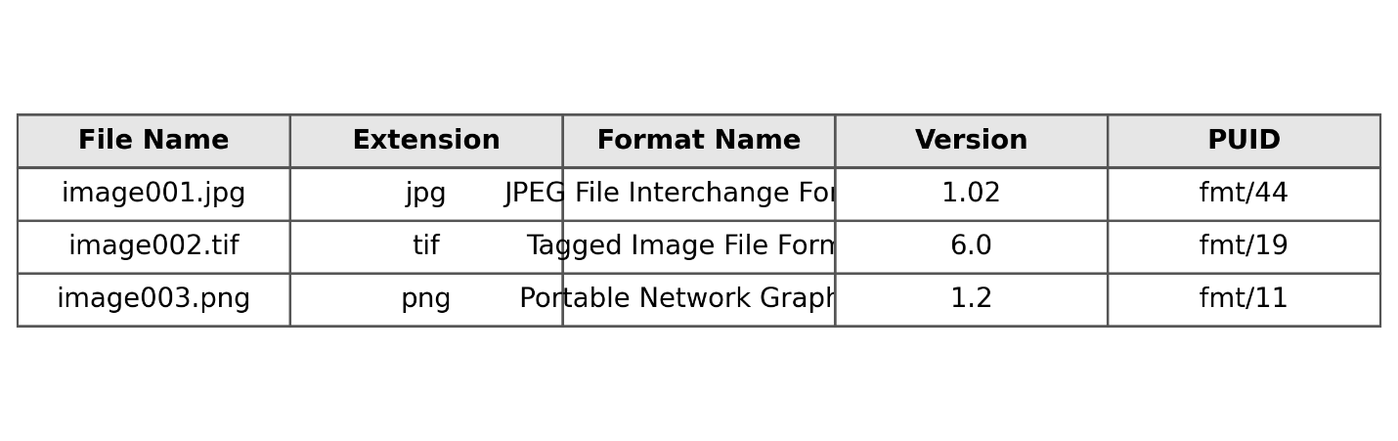Note. Format identification fields were generated automatically by DROID using PRONOM format signatures.
Appendix C
Data Structure for Format Analysis Dataset
This appendix presents the column structure used in the spreadsheet compiled from the DROID output for analysis in Microsoft Excel. The dataset included metadata fields necessary for identifying file formats, assigning Persistent Unique Identifiers (PUIDs), and evaluating preservation risk. Organizing the data in this structure supported the calculation of format frequencies and the assignment of preservation classifications.
Table C1
Data Structure for Format Analysis Dataset

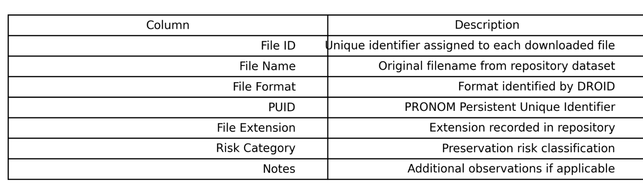
Note. The column structure shown in this table represents the spreadsheet format used to compile and analyze the output generated by the DROID format identification tool. Metadata fields were derived from the automated format identification process and supplemented with preservation risk classifications based on documentation provided in the PRONOM registry. The structure allowed the dataset to be organized for calculating format frequency distributions and evaluating preservation risk characteristics.
Appendix D
Sample Rows from the Format Analysis Dataset
This appendix provides example rows from the compiled spreadsheet used for analysis. These sample entries illustrate how the DROID output was organized into a structured dataset for identifying file formats and evaluating preservation risk. Including example rows helps clarify the relationship between the original DROID output and the spreadsheet used for analysis.
Table D1
Sample spreadsheet rows
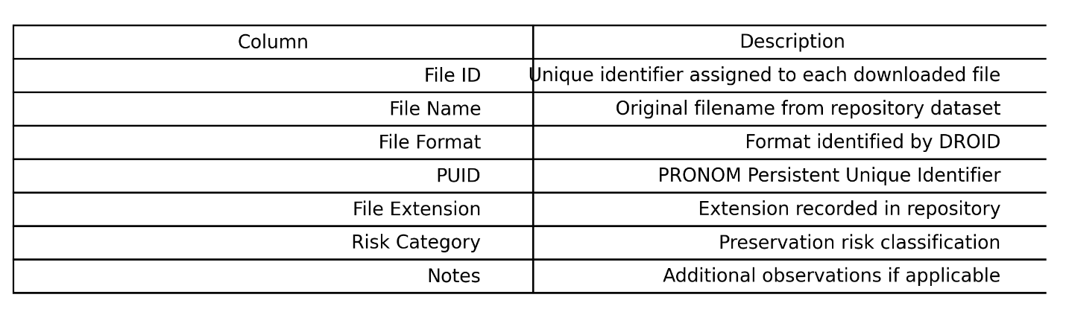
Note. The rows shown illustrate the structure of the compiled dataset used for analysis. Values were derived from the DROID format identification report and organized in a spreadsheet to support analysis of format prevalence and preservation risk. The rows are examples only and do not represent the complete dataset of 1,600 files analyzed in the study
Appendix E
Complete List of Identified Image Formats
The automated format identification process identified 22 distinct Persistent Unique Identifiers (PUIDs) corresponding to the image formats present within the sampled dataset. These identifiers represent the unique format signatures detected during the DROID scanning process.
Table E1
Identified Image Formats and Preservation Risk Classification
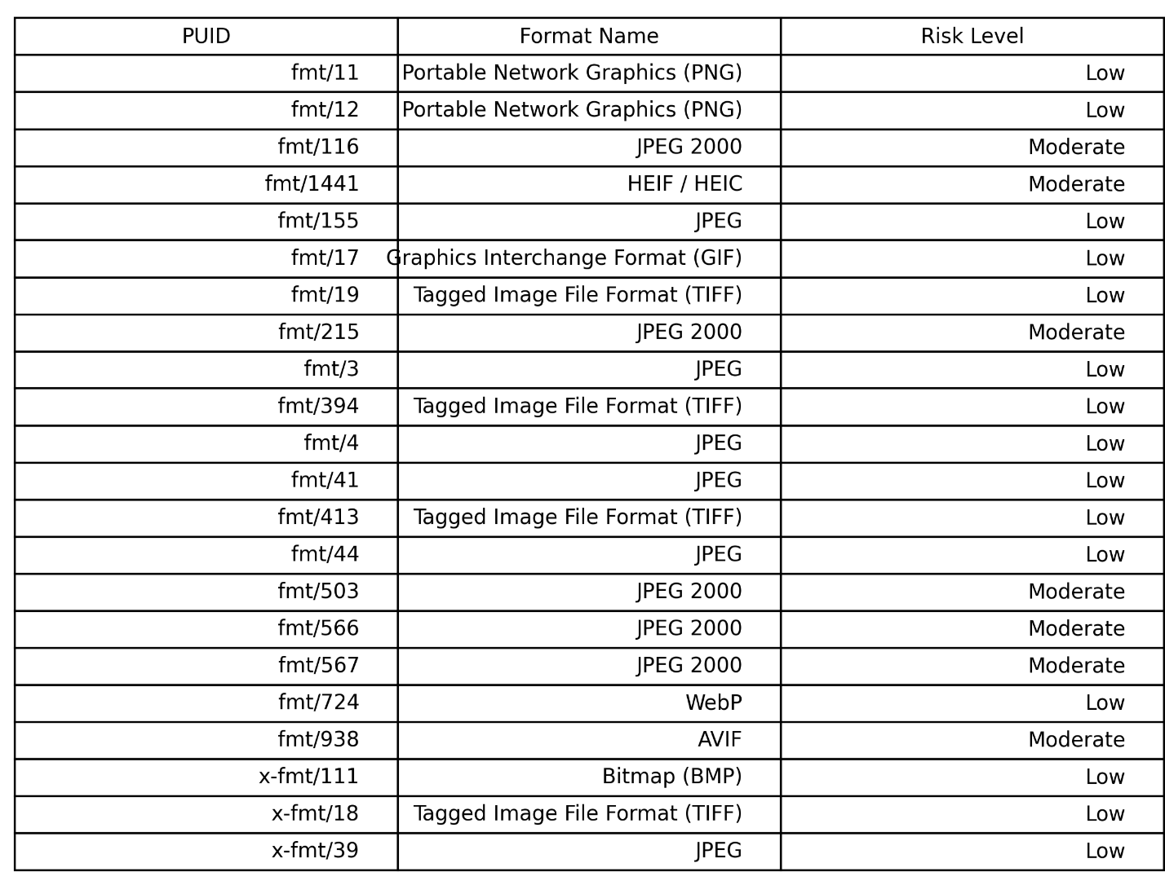
Note. The formats listed represent the Persistent Unique Identifiers (PUIDs) detected by the DROID format identification tool during analysis of the sampled dataset. PUIDs correspond to format signatures documented in the PRONOM technical registry and provide standardized identifiers for digital file formats. Preservation risk classifications were assigned using format documentation, software support, and adoption information provided by PRONOM, indicating the relative sustainability of each format for long-term digital preservation.
Appendix F
Preservation Risk Classification Criteria
Format risk levels were determined using technical documentation provided by the PRONOM registry. Risk classifications were assigned according to the following criteria.
Low Risk
Formats classified as low risk exhibit the following characteristics:
• Openly documented technical specifications
• Broad compatibility across operating systems and software tools
• Evidence of widespread adoption within digital imaging workflows
• Multiple independent software implementations capable of rendering the format
• Examples include JPEG, PNG, TIFF, GIF, and BMP
Moderate Risk
Formats classified as moderate risk exhibit one or more of the following characteristics:
• Limited software compatibility relative to widely adopted formats
• Dependence on specialized codecs or proprietary technologies
• Emerging adoption patterns with evolving software support
• Partial documentation or inconsistent implementation across platforms
Examples include JPEG 2000 variants, HEIF/HEIC, and AVIF.
High Risk
Formats classified as high risk would exhibit characteristics such as:
• Lack of publicly available technical documentation
• Dependence on obsolete or discontinued software environments
• Inconsistent or unreliable format identification
• Limited evidence of continued software support
No formats identified in the dataset met the criteria for high-risk classification.
Figure F1
Research Workflow for Format Identification and Preservation Risk A
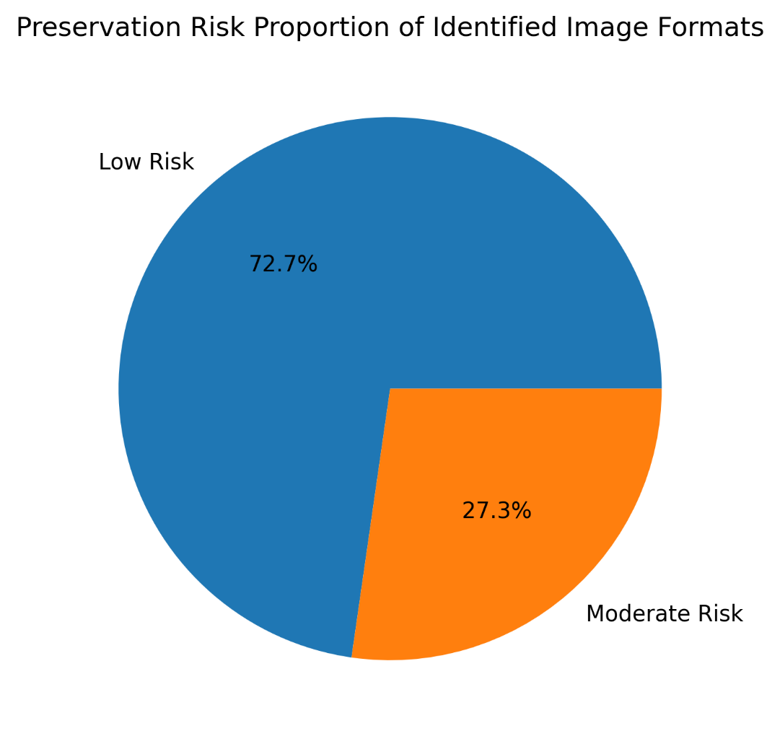
Note. The diagram illustrates the computational workflow used to collect, identify, and analyze file formats from the Harvard Dataverse repository. The process includes automated file sampling using a Python script, format identification with DROID, extraction of format identifiers, and evaluation of preservation risk using documentation from the PRONOM registry.
Appendix G
Research Workflow Diagram
Figure G1 illustrates the computational workflow used in this study to collect, identify, and analyze file formats from the Harvard Dataverse repository.
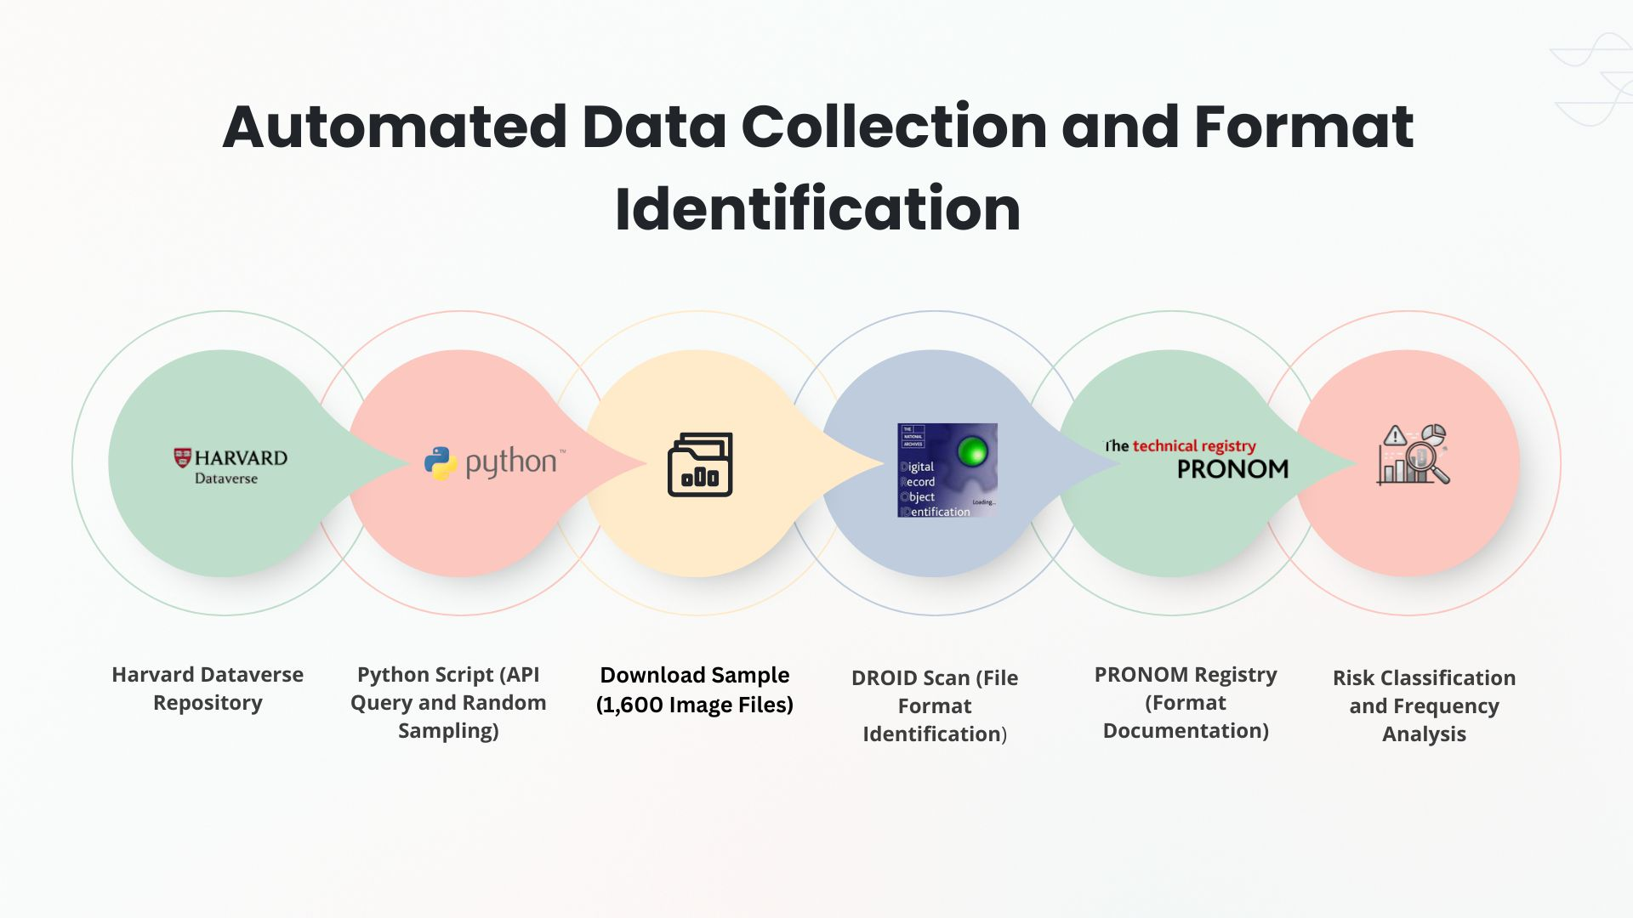
Figure G1
Research Workflow for Format Identification and Risk Assessment
Note. The workflow diagram summarizes the automated data collection and format identification procedures used in this study.

